Selected changes to APA 7th ed.

Reference list entries

- The publisher information is not included in the reference.
  - 6th edition style:
Brown, C. (2005). Learning styles. Toronto, ON: Macmillan.

  - 7th edition style:
Brown, C. (2005) Learning styles. Macmillan.

- Surnames and initials for up to 20 authors (instead of 7) should be provided.
  - 6th edition style:
Albertson, J., Miller, T., Choudhury, K., Wilson, P., Kelly, F.M., Taylor, T. B., …Lewis, T. (2012)
  - 7th edition style:
Albertson, J., Miller, T., Choudhury, K., Wilson, P., Kelly, F.M., Taylor, T. B., Castells, M., Thompson, V., Larson, A. W., Mortell, W.D., Lemieux, G., Sims, M.A., Wasiak, W., Green, P., Laughlin, P.T., Borjorek, I., Dudiyn, Y., Betts, L., …Lewis, T.
- DOIs are formatted the same as URLs. The label, DOI, is not included.
  - 6th edition style:
A metanalysis of studies in Educational Psychology, 1990-2010. Educational Psychology, 42(4), 5-21. doi: 10.1080/02626667.2018.1560449
  - 7th edition style:
A metanalysis of studies in Educational Psychology, 1990-2010. Educational Psychology, 42(4), 5-21. https://doi.apa. 10.1080/02626667.2018.1560449
- For e-books, the format, platform or device is no longer needed, and the publisher is included.
  - 6th edition style:
Brown, C. (2005). Learning styles [Kindle version].https:/10/1006/897-05-841-2373-2
  - 7th edition style:
Brown, C. (2005). Learning styles. Macmillan. https:/10/1006/897-05-841-2373-2
- URLs do not need to include “Retrieved from,” unless a retrieval date is needed.
The websiter name is included , and web page titles are italized.
  - 6th edition style:
Adzuki, B. (2006, November 3). Microsoft takes a page out of Apple’s business plan. Retrieved from https://www.technews/industry/business-40519127
  - 7th edition style:
Adzuki, B. (2006, November 3). Microsoft takes a page out of Apple’s business plan. https://www.technews/industry/business-4051912
- For any reference where the author and publisher are an exact match, the publisher is omitted.
  - 6th edition style:
American Psychiatric Association. (2013). Diagnostic and statistical manual of mental disorders (5th ed.). Author. https://doi.org/10.1176/appi.books.9780890425596
  - 7th edition style:
American Psychiatric Association. (2013). Diagnostic and statistical manual of mental disorders (5th ed.). https://doi.org/10.1176/appi.books.9780890425596

In-text citations

- For in-text citations with three or more authors, use only the first author’s name and “et al.” right from the first citation.
  - 6th edition style:
First mention: (Lesh, Moore, Vaugh, & Parker, 2018)

  - 7th edition style:
First mention: (Lesh, et al., 2018)

Formatting

- On a title page, students are no longer required to include a running head unless requested by an instructor.
  - 6th edition style:
Running head: TITLE OF YOUR PAPER

  - 7th edition style:
NO running head on student’s papers.

- On the title page, students are required include page elements of course number and name on the title page unless otherwise directed by their instructors
  - 6th edition style:
No special requirements for students

  - 7th edition style:
Your Name
Faculty of Humanities and Social Sciences, Athabasca University
ENGL 255: Introductory Composition
Dr. Professor’s Name
November 3, 2020

- No abstract or keywords are required for student papers unless required by an instructor.
  - 6th edition style:
Abstracts and keywords required for both student and professional papers

  - 7th edition style
No abstracts or keywords are required for student papers. They are still required for professional papers.

- On the title page, the title of the paper should be in title case, bold, and centered.
  - 6th edition style:
The Trouble With Cats: A Qualitative Study of Dog Owners’ Attitudes Toward Feline Behavior

  - 7th edition style:
The Trouble With Cats: A Qualitative Study of Dog Owners’ Attitudes Toward Feline Behavior

- Double spacing is now required
  - 6th edition style: (allowed)
In the transition from 6th to 7th edition APA style, not much has changed in the way citations are formatted, so if you are comfortable with writing citations according to the 6th edition rules then 7th edition should present no problems.

  - 7th edition style
In the transition from 6th to 7th edition APA style, not much has changed in the way citations are formatted, so if you are comfortable with writing citations according to the 6th edition rules then 7th edition should present no problems.

(cont.)

- Headings for levels 1-5 have changed. All headings are bold and levels 3 and 5 are also italic.
  - 6th edition style
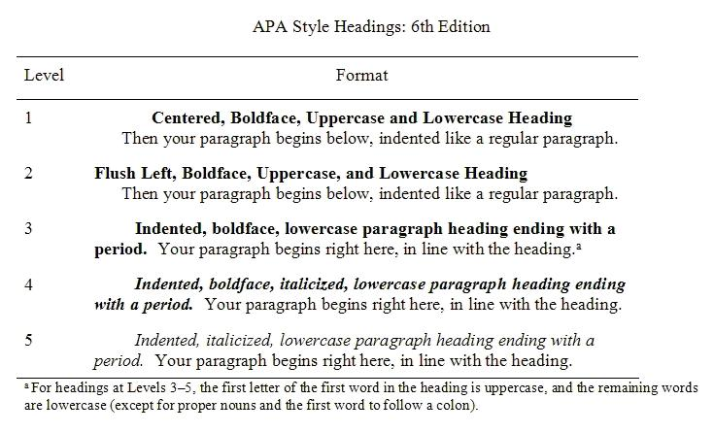

  - 7th edition style

APA Headings
Level | Format
1 | Centered, Boldface, Title Case Heading  Text starts a new paragraph.
2 | Flush left, Boldface, Title Case Heading  Text starts a new paragraph.
3 | Flush Left, Boldface Italic, Title Case Heading  Text starts a new paragraph.
4 | Indented, Boldface Title Case Heading Ending With a Period. Paragraph text continues on the same line as the same paragraph.
5 | Indented, Boldface Italic, Title Case Heading Ending With a Period. Paragraph text continues on the same line as the same paragraph.

For a fuller description of changes to the 7th edition, see: https://apastyle.apa.org/instructional-aids/whats-new-7e-guide.pdf

